ARKO Art Studio 2026

Arts Council Korea (ARKO) operates ARKO Art Studio Program to promote global artistic creation and cultural exchange. The program provides a foundation for creative work and research, while offering a platform for exchange that fosters the expansion of contemporary artistic discourse to both domestic and international visual artists. We look forward to receiving applications from talented artists to share their creative vision and explore new possibilities.

○ About ARKO Art Studio
■ Residency Venue: ARKO Art Studio (5, Pyeongchang 31-gil, Jongno-gu, Seoul, Republic of Korea)
■ Facilities
- Private Studio (31~52㎡, Wireless Internet available), Outdoor Performance Space, etc.
* Five individual studios: Each approximately 31㎡, 40㎡, 42㎡, 43㎡, and 52㎡
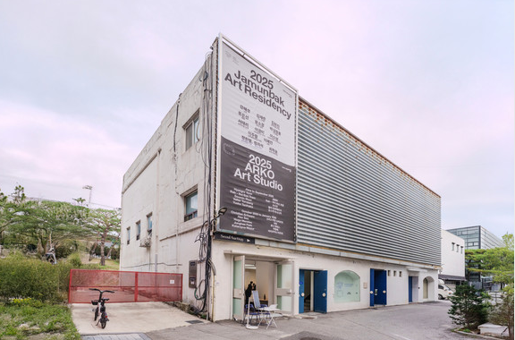 | 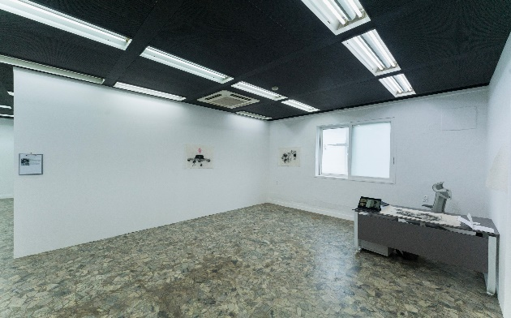
Studio Complex (outdoor) | ARKO Art Studio (indoor)
■ Residency Period: Applicant may apply for one term only (4 months)
- 3rd term: March–July 2026 (5 Artists)
- 4th term: August–December 2026 (5 Artists)
■ Number of Artists: 5 artists per term / 10 artists in total
※ Artists of all nationalities are eligible to apply
■ Main Programs
- K-culture tours, professional matching, studio visits, artist mentoring, open studios, networking programs, and ARKO Art Studio exhibition (scheduled for 2027), etc.
- Program details are subject to adjustment in consultation with the selected artists.
■ Benefits
- For all participating artists
- Private studio
- Production support: KRW 500,000 per month
- Living allowance: KRW 500,000 per month
- Additional Support for International Artists (non-Korean nationals)
- Round-trip airfare: reimbursement of actual expenses up to KRW 2,000,000
- Accommodation: reimbursement of actual expenses up to KRW 1,200,000 per month
* Accommodation support for international artists may be provided in the form of housing instead of reimbursement.
■ Responsibilities of applicants
- Meals, local transportation, visa and Alien Registration Card fees etc.
- Travel and medical insurance
* Selected artists should submit a copy of insurance certificate to ARKO. Those who do not provide their insurance certificate may have their residency program canceled.

○ Application Guidelines
■ Eligibility
- Only individual applicants will be considered; teams and collectives are not eligible
- Applicants must possess a minimum of five years of professional experience in the visual arts including research and curating.
- Applicants must be eligible and able to obtain a visa for a minimum stay of four months in South Korea
- (If non-Korean) Must have no legal or financial restrictions on international wire transfers or the opening of a bank account in South Korea
- Applicants must be fluent in English
- Important: Artists selected for the 2026 ARKO Regular Grant Programs are not eligible to apply for ARKO Art Studio
■ Application Period: February 2 (Mon) – February 18 (Wed), 2026
■ Required Application Materials: Applications must be prepared using the separately provided application form (*.ppt).
no | Required Documents | Length / Format | Notes
1 | Personal Statement | 500 words maximum length, designated format (*.ppt) | -
2 | Artistic Practice Plan | 500 words maximum length, designated format (*.ppt) | -
3 | Portfolio | Select from up to 10 image files (*.jpg, *.pdf), or one video file (*.avi, *.mp4 / up to 5 minutes) | Submit with digital file (images of artwork, video, introduction of artwork, etc.), designated format (*.ppt)
4 | CV | designated format (*.ppt) | Include exhibitions, projects, residency, awards, and education history
■ How to Apply: Submit application to email (arkoresidency@arko.or.kr)
- Include all materials referenced above as attachments up to 100MB
- Submitted materials will be deleted after the selection process is complete.
- Application deadline: February 18, 2026 (Wed), 23:59 (KST)
■ Results: Applicants will be notified of result by March 11, 2026 (Wed), 17:00 (KST) (tentative)
- Final results will be posted on ARKO website (https://www.arko.or.kr), All dates and program details are subject to change.
■ Inquiries: arkoresidency@arko.or.kr / +82-2-760-4540

(Attached) ARKO Art Studio Floor plan

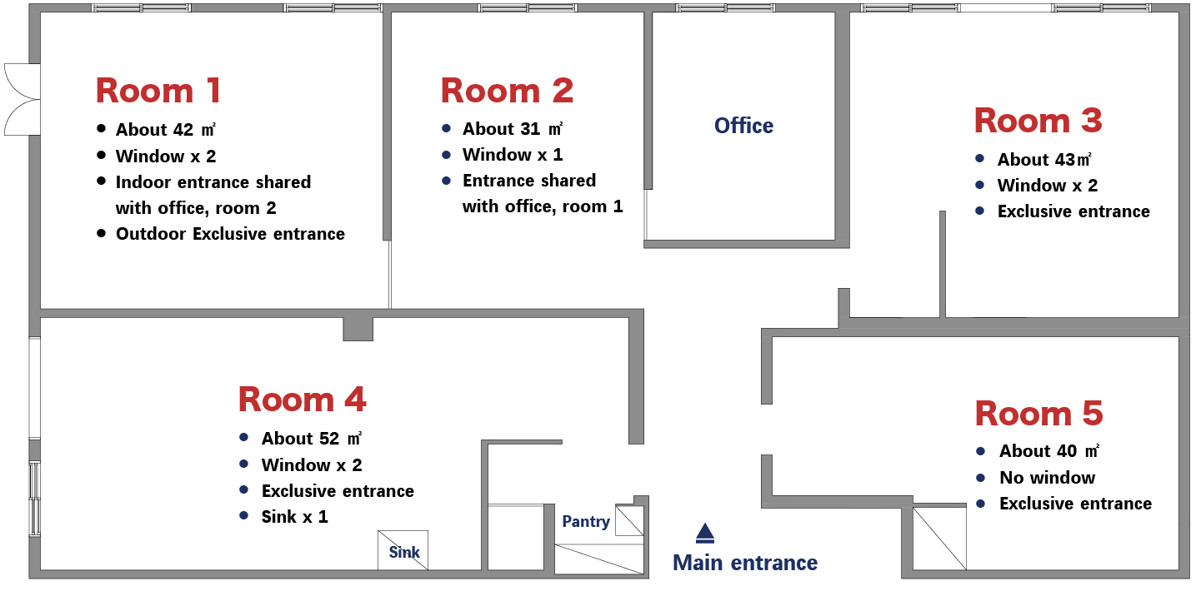
* Please note that the studios vary in size, with one studio each measuring 31㎡, 40㎡, 42㎡, 43㎡, and 52㎡.
* Studios will be assigned to resident artists by lottery.

